**2. System Environment**

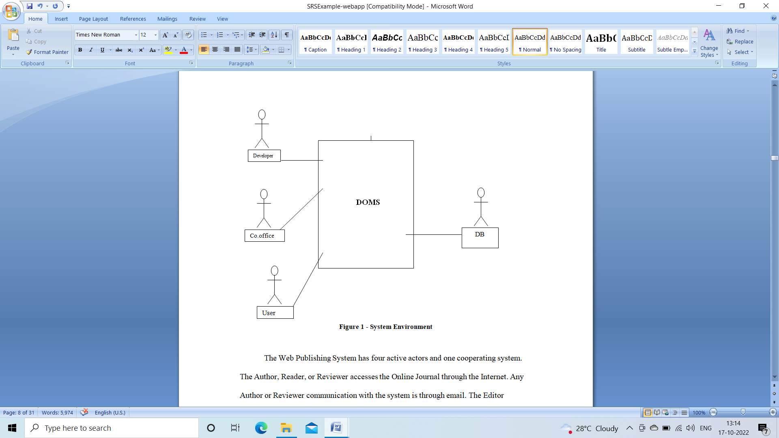

**Developer**

Developer assembles all the sensors and places them in the correct place. The maintenance of the sensors will be handled by the developer. If any sensor fails to work, developer replaces them.

**Corporate Office**

Corporate office takes the information from the SMS and accordingly sends the workers to take necessary action.

**User**

While passing user needs to check the LCD display to know whether drainage is overflowed or not. If drainage is not properly maintained then he/she thinks of the best way to reach destination.